41.46: a) b) The negative of the result of part (a), 666 eV. c) The radius of the ground state orbit is inversely proportional to the nuclear charge, and 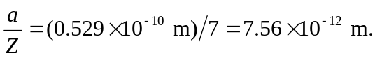
d) 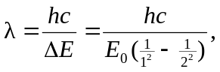 where 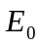 is the energy found in part (b), and 